Screenshot 1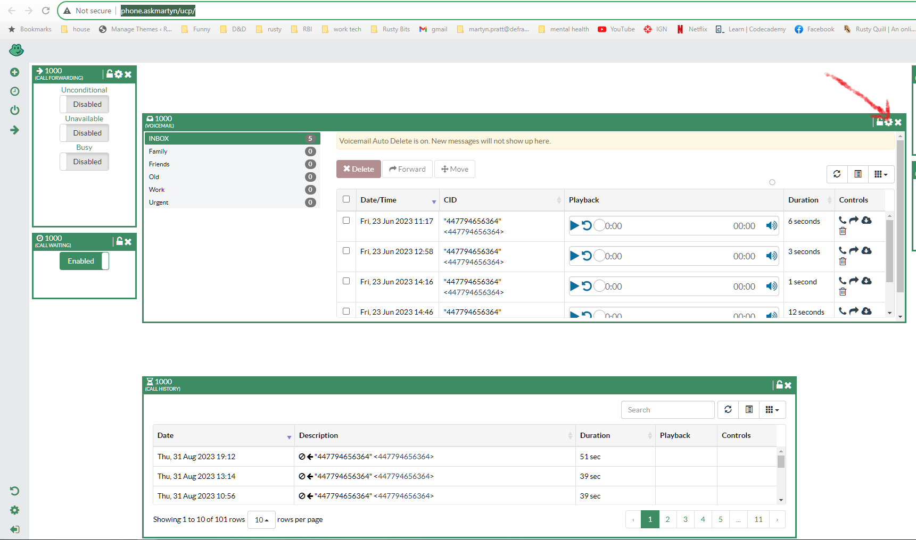

1 – login to the pbx ucp url credentials under voicemail admin in 1password and press this very small and difficult to find cog in the menu highlighted in Screenshot 1 with a red crayon

Screenshot 2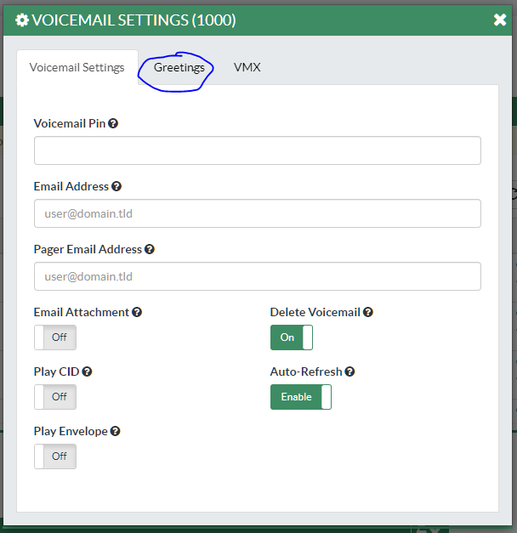

Press “Greetings” in the next menu highlighted with a normal blue pen in Screenshot 2

Screenshot 3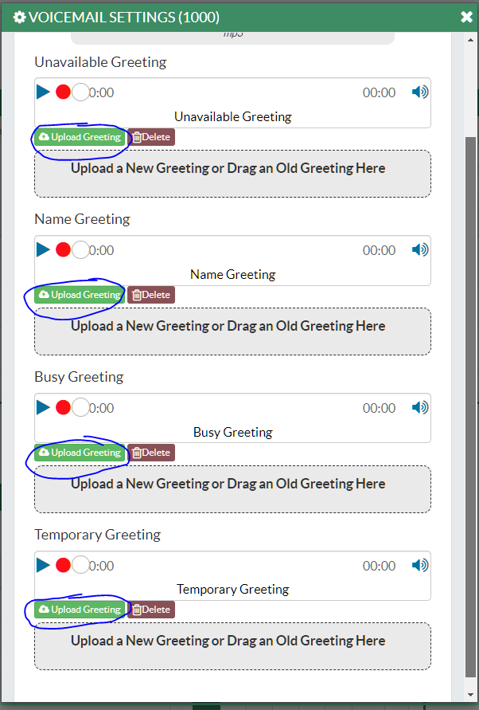

Upload the greeting to all the options. Who really knows which one people will get? Doesn’t matter. They're all the same. I used the blue pen again.